2. Life Cycle Plan (LCP)
3. City of Los Angeles Personnel Department Mobile Applications
4. Team 02
5. ANUSHREE SRIDHAR - Software Architect
6. SHREYA KAMANI - Project Manager
7. DIVYA REDDY - Requirements Engineer
8. PATTRA THONGPRASERT - Operation Concept Engineer
9. ABHISHEK TRIGUNAYAT - Prototyper
10. TRAVIS JONES - Feasibility Analyst
11. WILLIAM EVERTON - IIV and V
12. Image7.png
13. USC-CSSE

# Version History

|  |  |  |  |  |  |
| --- | --- | --- | --- | --- | --- |
| **Date** | **Author** | **Version** | | **Changes made** | **Rationale** |
| 09/26/13 | Shreya Kamani | 1.0 | * The original template was taken from the ICSM guidelines and modified as per the requirements of the project * The Skills that are possessed by all the team members have been added * The activities and the milestones done by the team in the exploration phase are also added | | * To develop the Life Cycle plan for the project of Team 02 |
| 10/14/13 | Shreya Kamani | 1.1 | * Topics of Monitoring and Control and Resources were added * Roles of the team members in the Valuation phase were added | | * To modify version 1.0 according to the requirements of the FC package |
| 10/20/13 | Shreya Kamani | 1.2 | * Topics of resource estimation were modified and new screen captures were added. * Roles For 577b were added | | * To modify version 1.1 as per the changes requested in the FCR ARB. |
| 10/31/13 | Shreya Kamani | 1.3 | * Reviewed and verified content * Revised formatting for consistency | | * Revised for consistency according to retrospective analyis |
| 12/02/13 | Shreya Kamani | 1.4 | * Revised Content * Added Section 6.1 | | * To modify version for DCR ARB |

# Table of Contents

Version History 2

Table of Contents 3

Table of Tables 4

Table of Figures 5

1 Introduction 6

**1.1 Purpose of the LCP 6**

**1.2 Status of the LCP 6**

2 Milestones and Products 7

**2.1 Overall Strategy 7**

**2.2 Project Deliverables 8**

**2.2.1 Exploration Phase 8**

**2.2.2 Valuation Phase 9**

3 Responsibilities 10

**3.1 Project-specific stakeholder’s responsibilities 10**

**3.2 Responsibilities by Phase 10**

**3.3 Skills 13**

4. Approach 14

**4.1 Monitoring And Control 14**

**4.1.1 Closed Loop Feedback Control 14**

**4.1.2 Reviews 14**

**4.1.3 Methods Tools and Facilities 15**

5. Resources 16

6. Iteration Plan 22

# Table of Tables

Table 1 - Artifacts Deliverable in Exploration Phase 8

Table 2 - Artifacts deliverable in Valuation Phase 9

Table 3 - Artifacts deliverable in Foundations Phase 9

Table 4 - Roles and Responsibilities 10

Table 5 - Skills 13

Table 6 - Tools and Usage 15

Table 7 - Scale Factors for Module 19

Table 8 - Cost Drivers for Module 1,2 21

Table 9 - Construction iteration capabilities to be implemented 22

Table 10 - Construction iteration capabilities to be tested 22

# Table of Figures

Figure 1 - Overview of the Whole System - COINCOMO 16

Figure 2 - Overview of system 17

Figure 3 – Scale Factors 18

Figure 4 – Cost Drivers Server 19

Figure 5 – Cost Drivers UI 19

# 1 Introduction

## 1.1 Purpose of the LCP

It is very essential that all the Stakeholders understand the flow of the project. Also the roles of every team member and skills of all the developers are to be understood. Hence this makes it essential to develop a concrete LCP so as to describe the complete strategy, artifacts and responsibilities of everyone involved.

## 1.2 Status of the LCP

Current version of life cycle plan, which is version 1.1 will include Milestones and products that includes the overall strategy, Approach and Resources too.

Monitoring and control, Methods, tools and facilities and Resources along with the schedule of effort and schedule for every module are also included.

#### Assumptions

* + The duration of 2 semesters for the project, which are 12 weeks in Fall 2013 and 12 weeks in Spring 2014 is sufficient for the completion of this project
  + There are seven people working on the project including one DEN student is an optimum number of staff required to do this project in the given schedule
  + The client will be available for regular meetings, to discuss the progress, issues and other concerns regarding the project that is proposed by them
  + All the roles and responsibilities assigned to each member of the team will be carried on efficiently to meet the milestones of the project
  + Client is willing in terms of monetary investment, according to the needs of the project

# 2 Milestones and Products

## 2.1 Overall Strategy

The development of the Mobile Application for the Los Angeles Personnel department is going to be from the scratch. The project will use the ARCHITECTED AGILE process of the Incremental Commitment Spiral Model as all the components are going to be custom made.

**Exploration Phase**

**Duration**: 09/13/13 – 09/27/13

**Concept:** The team should focus on understanding the current system and design the business work flow in the Exploration phase and would conduct regular weekly meetings with the client to discuss and understand current system, requirements, concerns and progress.

**Deliverables:** Valuation Commitment Package

**Milestone:** Valuation Commitment Review

**Strategy:** One Incremental Commitment Cycle

**Valuation Phase**

**Duration**: 09/27/13 – 10/21/13

**Concept:** To evaluate the risks the SCS including the LAPD Personnel and IT department representatives and the developers will have win-win negotiations. The team will gather requirements and then along with the Stakeholders they will prioritize the requirements and a proposed system will be defined by these win-win negotiations. Based on this definition the team prepares initial prototypes of the high risk win conditions.

**Deliverables:** Core Foundations Commitment Package, Draft Foundations Commitment

Package, Project Effort Reports, Project Plan, Progress Reports, Prototype Report,

System and Software Architecture Description, Supporting Information Document.

**Milestone:** ARB FCR

**Strategy:** One Incremental Commitment Cycle

**Foundation Phase**

**Duration**: 10/21/13 – 12/09/13

**Concept:** Continue risk assessment. The team will conduct meetings with the Stakeholders a proposed system architecture will be defined. Based on this definition the team prepares initial prototypes of the high risk win conditions. Merge the modules and define test cases for each modules.

**Deliverables:** Core Development Commitment Package, Draft Development Commitment

Package, Project Effort Reports, Project Plan, Progress Reports, Prototype Report,

System and Software Architecture Description, Supporting Information Document, Test Case and Plan, Transition Plan.

**Milestone:** ARB DCR

**Strategy:** One Incremental Commitment Cycle

## 2.2 Project Deliverables

### 2.2.1 Exploration Phase

Table 1 - Artifacts Deliverable in Exploration Phase

|  |  |  |  |
| --- | --- | --- | --- |
| **Artifact** | **Due date** | **Format** | **Medium** |
| Client Interaction Report | 9/20/2013 | .doc, .pdf | Soft copy |
| Valuation Commitment Package:   * Operational Concept Description (OCD) Early Section * Life Cycle Plan (LCP) Early Section * Feasibility Evidence Description (FED) Early Section | 09/27/2013 | .doc, .pdf | Soft copy |
| Bugzilla report | Every Wednesday | Text | Bugzilla Website |
| Project Plan | Every other Monday | .mpp | Soft copy |
| Progress Report | Every other Monday | .xls | Soft Copy |

### 2.2.2 Valuation Phase

Table 2 - Artifacts deliverable in Valuation Phase

|  |  |  |  |
| --- | --- | --- | --- |
| **Artifact** | **Due date** | **Format** | **Medium** |
| Client Interaction Report | 9/20/2013 | .doc, .pdf | Soft copy |
| Foundation Commitment Package:   * Operational Concept Description (OCD) Early Section * Life Cycle Plan (LCP) Early Section * Feasibility Evidence Description (FED) Early Section | 10/21/2013 | .doc, .pdf | Soft copy |
| Bugzilla report | Every Wednesday | Text | Bugzilla Website |
| Project Plan | Every other Monday | .mpp | Soft copy |
| Progress Report | Every other Monday | .xls | Soft Copy |

### 2.2.2 Foundations Phase

Table 3 - Artifacts deliverable in Foundations Phase

|  |  |  |  |
| --- | --- | --- | --- |
| **Artifact** | **Due date** | **Format** | **Medium** |
| Draft DC Package | 12/2/2013 | .doc, .pdf | Soft copy |
| Development Commitment Package:   * Operational Concept Description (OCD) * Life Cycle Plan (LCP) * Feasibility Evidence Description (FED) * TCP and TC | 12/09/2013 | .doc, .pdf | Soft copy |
| Bugzilla report | Every Wednesday | Text | Bugzilla Website |
| Project Plan | Every other Monday | .mpp | Soft copy |
| Progress Report | Every other Monday | .xls | Soft Copy |

# 3 Responsibilities

## 3.1 Project-specific stakeholder’s responsibilities

This project has only the typical stakeholder’s responsibilities. The stakeholder includes client, project manager, operational concept engineer, requirement engineer, prototyper, feasibility analyst, software architecture, and IIV&V.

## 3.2 Responsibilities by Phase

Table 4 - Roles and Responsibilities

|  |  |  |  |  |  |
| --- | --- | --- | --- | --- | --- |
| **Team Member**  **Role** | **Exploration** | **Valuation** | **Foundations** | **Development- Construction Iteration** | **Development- Transition Iteration** |
| Leo/Keith:  **Client/ Maintainer** | **Client:**  - Provide current system information  - Explain current system workflow  - Define desired mobile application system and the requirements to achieve it | - Agree on the Win conditions  - Feedback on the FCR ARB  - Giving information about the current system | -Obtain server details from the client  -Obtain client requirements. | -Provide review after the first Core Capability and recommend changes. | -Installation of the system. |
| Shreya Kamani  **Project Manager** | - Creating the Project Plan  - Assign tasks to team members.  -Maintain the non-component activity and the website under bugzilla | - Create bi weekly project plans  -Develop the LCP version 1.0.  -Record Project Progress  -Communicate with the clients | -Conduct Team meetings  -Assign roles.  -Assist in prototyping of front end  -Modify and Update LCP | -Conduct Team meetings  -Assign roles.  - Assist Team member in other activities | -Conduct Team meetings  -Assign roles.  - Assist Team member in other activities |
| Pattra Thogaprasert  **Operational Concept Engineer** | - Develop the OCD.  - Analyze the current System.  - Identify shared vision  -Assess operational concept | - Establish new operational concept  - Explore alternatives  - Identify objectives, constraints, and priorities  - Identify objectives, constraints, and priorities  - Identify organizational and operational concepts | - prototype front-end of the application | - Implement the application  - Ensure the implementation follow the operational concept and agree with shared vision | - Implement the application  - Ensure the implementation follow the operational concept and agree with shared vision  - train City of LA Personnel Department’s maintainer |
| Divya Reddy  **Requirement Engineer** | **-** Gather the current system details  - Analyses of Requirements  - Negotiation of requirements  **-**Assist in maintaining Bugzilla | - Identify objectives, constraints, and priorities  -Analysis of the high risk components of the requirements  -maintaining the Winbook criteria up-to-date | - Get the Phonegap working with Android  - Test if Java can be used along with Phonegap for application development | - testing the application  - creating test cases  - Ensure the development product satisfy the requirements | testing the application  - creating test cases  - Ensure the development product satisfy the requirements |
| William Everton:  **IIV&V** | **-** Review the project artifacts.  - Keep track of the win Conditions being the shaper of the project. | - Review the project artifacts.  - Keep track of the win Conditions being the shaper of the project. | - Review the project artifacts.  - Keep track of the win Conditions being the shaper of the project. | - Review the project artifacts.  - Keep track of the win Conditions being the shaper of the project. | - Review the project artifacts.  - Keep track of the win Conditions being the shaper of the project. |
| Travis Jones:  **Feasibility Analyst** | Risk Assessment | -Business Case  -Feasibility Evidence  -Risk Assessment  -Decision Process  -Personas | -NDI/NCS Evaluation  -Risk Assessment  -Prototyping UI | -Risk  Assessment  -Tester | -Risk  Assessment  -Tester |
| Anushree Sridhar  **System Architect/**  **UML Modeller/**  **Implementer** | - Created project plan for week 1  - Helped with various documents for VCP | - Physical and logical architecture  -Use case diagram  - System Context diagram  - Artifacts and information diagram | - Define technology dependent architecture  - Decide on style, patterns and frameworks  - Create required UML models  - Complete SSAD | - Help with the implementation of the project  - Ensure the implementation is true to the architecture specified | **-** Help perform core-capability drive-through  - Create user manual  - Make required changes specified by the client |
| Abhishek Trigunayat  **Prototyper** | -Create the progress report  - Analyze the current System  - Assist in developing the OCD  - Assist in developing the website for project | -Create the progress report  - Assist in developing the LCP  -Prototyping for the database connectivity  -Prototyping for the send notification  -Prototyping for subscription | -Create the progress report  -Integrating the UI with the database, subscription and sending notification | -Create the progress report  -Prototyping PhoneGap with Android  -Prototyping PhoneGap with iOS  -Implementing the project | -Create the progress report |

## 3.3 Skills

Table 5 - Skills

|  |  |  |  |
| --- | --- | --- | --- |
| **Team Member** | **Role** | **Existing Skills** | **Required Skills** |
| **Shreya Kamani** | Project Manager  Lifecycle Planner | Communication Skills, Planning & Coordination Skills, Time Management    Microsoft Project  Microsoft Office  COCOMO II  COINCOMO | Agile management experience  COCOMO II |
| **Pattra Thongprasart** | Operational Concept Engineer | COCOMO II  COINCOMO  Microsoft Visio | UML Modeling |
| **Divya Reddy** | Requirement Engineer  Prototyper | Requirement Negotiation skills UML Modeling  COINCOMO  COCOMO II  Android SDK  Java | UML Modeling  COCOMO II  Android SDK  iOS  Java  DB2 |
| **Abhishek Trigunayat** | Prototyper | Microsoft Project  Microsoft Office COINCOMO  Java  DB2 | COCOMO II  Android SDK  iOS  Java  DB2 |
| **Anushree Sridhar** | Software Architect  Prototyper | COCOMO II  Rationale Rose  Java | UML coding  COCOMO II  Android SDK  Java  iOS  DB2 |
| **William Everton** | IIV&V  Quality Focal Point | Bugzilla | Bugzilla  Quality Control and Assessment |
| **Travis Jones** | Feasibility Engineer | Analysis skills  COINCOMO | Feasibility Analysis  COCOMO II |

# 4. Approach

## 4.1 Monitoring And Control

### 4.1.1 Closed Loop Feedback Control

The IIV&V is responsible for bug tracking. BUGZILLA is the tool that is used for bug tracking. Each team member needs to report and resolve the defects related to his/her roles in the project.

The Winbook lists all the requirements and the risks and also prioritizes the requirements.

The Team uses Google drive and Github to communicate all the matters within the members and to keep all the artifacts organized. The team also uses the DEN discussion forum and blog for sharing files and for communicating.

### 4.1.2 Reviews

Weekly group review: This review is made every week so that each team member can contribute their work.

IIV&V: By the den student, all artifacts are reviewed and bugs are released for each one of them.

Win-Win Negotiations: Negotiations and review in which all values from the SCS are noted. Also help to estimate and, prioritize and order the requirements

### 4.1.3 Methods Tools and Facilities

Table 6 - Tools and Usage

|  |  |  |
| --- | --- | --- |
| **Tools** | **Usage** | **Provider** |
| Microsoft Office | Used for documenting deliverables, LCP, OCD, FED,  Project plan, Progress Report. | Microsoft |
| Appery.io | To create UI prototypes | Open Source |
| Java SE, Java EE | TO create backend prototypes | Oracle |
| DB2 express | For database Purpose | IBM |
| Apache Tomcat Server | Sever | Apache |
| BitBucket | Used for sharing Files | Open Source |

# 5 Resources

Total Number of Team members = 7

Total Project Duration = 12 weeks in Fall 2013 and 12 weeks in Spring 2014

Language used = Java, DB2, HTML

Figure 1 - Overview of the Whole System - COINCOMO

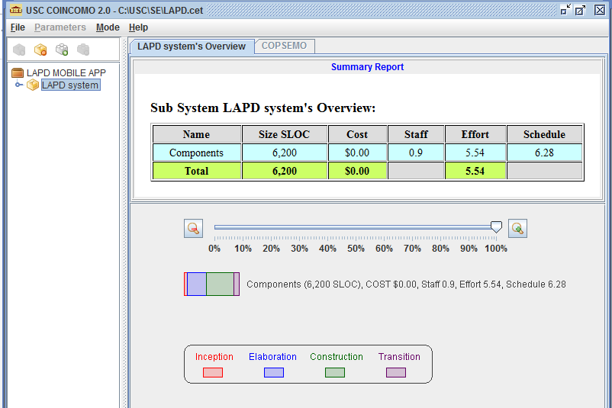

Figure 2 - Overview of LAPD system 1: Server and UI component

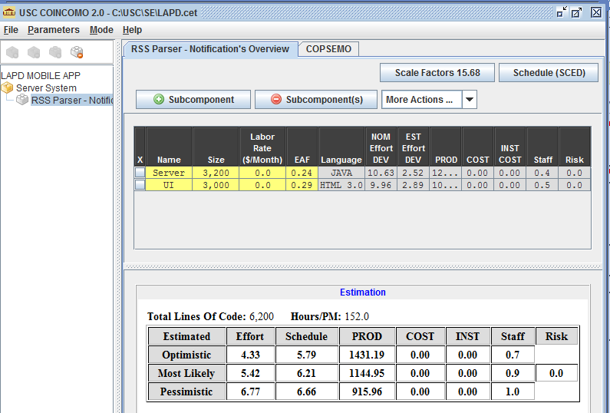

The Tables below describe the Scale Factor Ratings and the Cost Driver Ratings for each Component

Figure 3 - Scale Factors

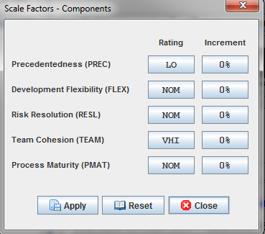

Table 4 - Scale Factors for Module

|  |  |
| --- | --- |
| **Scale Driver** | **Value – Component** |
| PREC | LO – Largely unprecedented |
| FLEX | NOM- There is basic need for conformance with other values. |
| RESL | NOM- the criticality of risk is nominal |
| TEAM | VHI – Team members are highly cooperative |
| PMAT | NOM- between level 2 and 3 |

Figure 4 - Cost Drivers Server

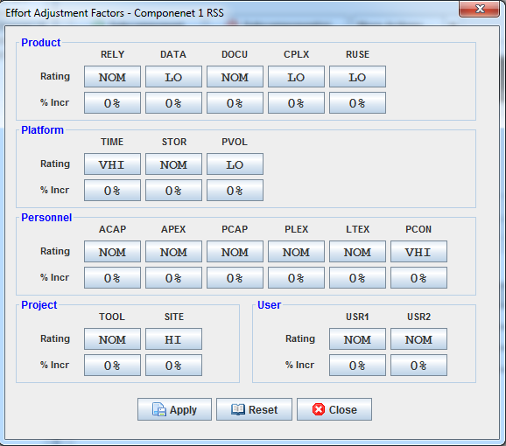

Figure 5 - Cost Drivers UI

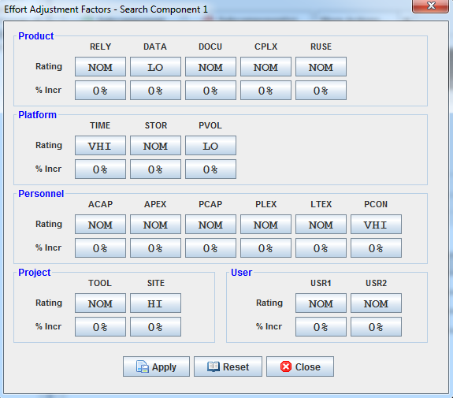

Table 8 - Cost Drivers for Components 1,2

|  |  |  |
| --- | --- | --- |
| **Effort Driver** | **Value – Component 1** | **Value- Component 2** |
| RELY | NOM- moderately easily Recoverable financial losses if this fails. | NOM- moderately easily Recoverable financial losses if this fails |
| DATA | LO- Since the ratio of D/P is very low. | LO- Since the ratio of D/P is very low. |
| CPLX | LO- Moderately Complex DB queries. | NOM- Complex queries for auto searching. |
| RUSE | LO – Nothing is reused | NOM – This module is used across the project. |
| DOCU | NOM- It abides to everything in the LCP | NOM- It abides to everything in the LCP |
| TIME | VHI- Since the assured run time / uptime of the system is 90%. | VHI- Since the assured run time / uptime of the system is 90%. |
| STOR | NOM- The use of Storage is less than 50 %. | NOM- The use of Storage is less than 50 %. |
| PVOL | LO- Major Changes are not required frequently. | LO- Major Changes are not required frequently. |
| ACAP | NOM- Analysts are able to capture requirements well. | NOM- Analysts are able to capture requirements well. |
| PCAP | NOM- Since the team is moderate rated programmer team. | NOM- Since the team is moderate rated programmer team. |
| PCON | VHI – annual turnover is around 3% / year | VHI– annual turnover is around 3% / year |
| APEX | NOM – The average experience of all team members is nominal. | NOM– The average experience of all team members is nominal. |
| PLEX | NOM– The average experience of all team members is nominal. | NOM– The average experience of all team members is nominal. |
| LTEX | NOM– The average programming language knowledge of all team members is nominal. | NOM– The average programming language knowledge of all team members is nominal. |
| TOOL | NOM – Basic tools | NOM – Basic Tools |
| SITE | HI- The clients and developers are in the same city. | HI- The clients and developers are in the same city. |

Hence, after the COINCOMO analysis the project will be able to be completed by 7 people.

# 6. Iteration Plan

## 6.1 Plan

This project composed of 2 iterations development phase; First iteration for the core capabilities including list jobs, send notification, and subscription to jobs and second iteration for the full integration testing. The following iterations are planned for the Core Capability Drive-through in development phase.

### 6.1.1 Capabilities to be implemented

Our project development phase can be divided into 2 iterations; all three capabilities goals will be developed and tested in the first iteration, then the full integration will be done in the second iteration. The priority level illustrates the order of the implementation. This level bases on priority value obtain from Win-Win session with the client. Table below shows the details of each capability.

Table 9: Construction iteration capabilities to be implemented

|  |  |  |  |  |
| --- | --- | --- | --- | --- |
| ID | Capability | Description | Priority | Iteration |
| OC-1 | List jobs | Job seekers can view existing jobs and current open jobs with details | 3rd | 1st |
| OC-2 | Send notifications | The system will send notifications via text message or email to potential job seekers who subscribe for the notification | 1st | 1st |
| OC-3 | Subscription to jobs | Job seekers can subscribe to receive notification for jobs they find interesting | 2nd | 1st |

### 

### 6.1.2 Capabilities to be tested

The capabilities that will be tested in the upcoming iteration in Development phase.

Table 10: Construction iteration capabilities to be tested

|  |  |  |  |  |
| --- | --- | --- | --- | --- |
| ID | Capability | Description | Priority | Iteration |
| OC-1 | List jobs | Job seekers can view existing jobs and current open jobs with details | 3rd | 1st |
| OC-2 | Send notifications | The system will send notifications via text message or email to potential job seekers who subscribe for the notification | 1st | 1st |
| OC-3 | Subscription to jobs | Job seekers can subscribe to receive notification for jobs they find interesting | 2nd | 1st |

### 6.1.3 Capabilities not to be tested

All three capabilities agreed on Winbook will be developed and tested in the first iteration. The full integration will be conducted in the second iteration.